**SPRING 2021 – CS443**

**QUIZ APPLICATION - PROJECT DESCRIPTION DOCUMENT**

**Project Statement:** The main objective of the Quiz Application project is to develop an app for instructors and students. This is a multiple-choice quiz app. I wanted to develop this app as I can get to know different services and modules in android app development.

Also, since this is one of the projects that involve databases, communicating between different activities, I wanted to learn those implementing the app. Also, there are lot of apps on android market for quiz application, but this is just my way of giving a try implementing things.

This app can be mainly used by students and instructors as a platform for quiz exams. This is a simple app and no specific requirements.

**Application Design:** In this app we have the following functionalities.

1. **Login/Register:** The welcome screen of the app is Login/Register Page. User can Login/Register (both in the same UI screen). The main field that differentiates the user is an account type which is drop down. Please find the screenshot below:

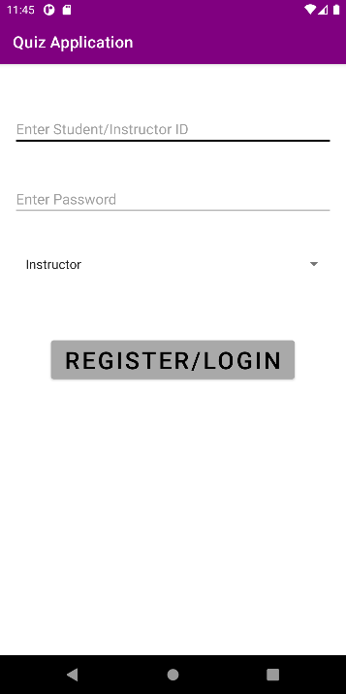

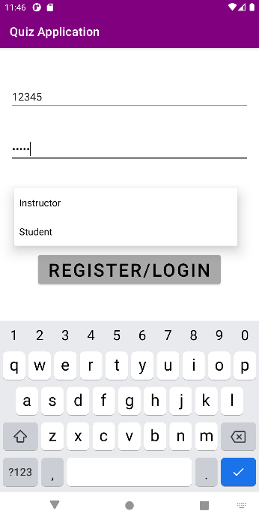

If the user is new, when he clicks the Register/Login button, an account will be created. If the user is already registered, then it will login the user. Once the login/registration is successful, a toast message will be displayed. If the login/registration is not successful, a toast message is displayed as error. If the user is logged in as a student, then user will be taken to Student Home Page.

1. **Student Home Page:** The student home page is where student enters the quiz ID and take quiz. After the quiz is finished, he will be redirected to this page displaying the score of the quiz. Initially, the score of the quiz will be displayed as 0.

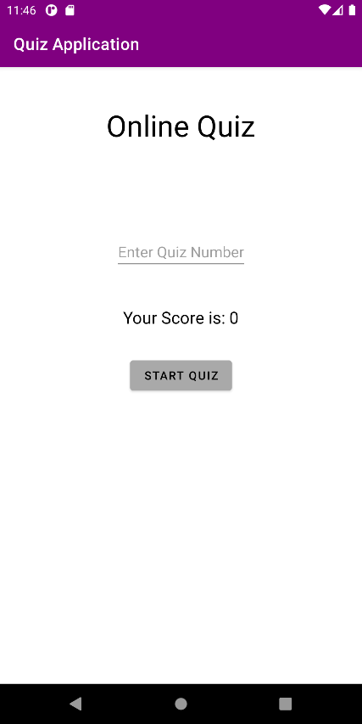 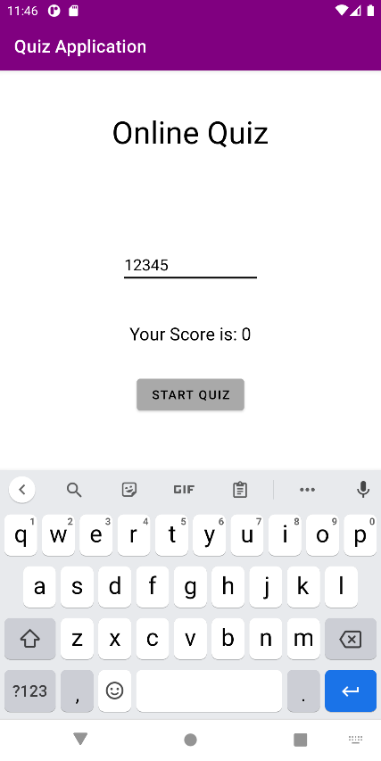

Once the start quiz button is pressed, the student will be taken to quiz activity page.

1. **Quiz Page:** On this page quiz id, score, question count and timer will be displayed on the top. Also, the question and multiple-choice options along with the confirm button will be displayed. The timer is default set to 10 minutes for now. Also, when the confirm button is pressed, the correct answer will be displayed. When the answer is displayed the button changes to next. When the answer for final question is displayed, then the button will be finish button which finishes the quiz.

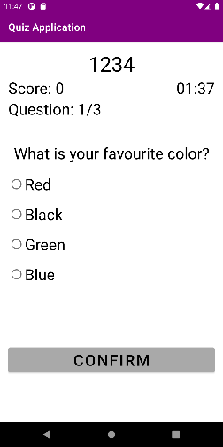 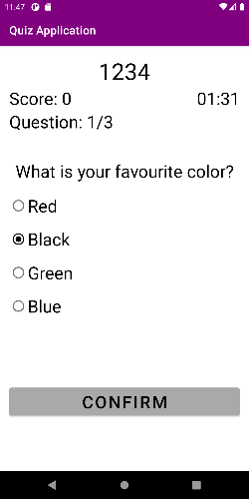 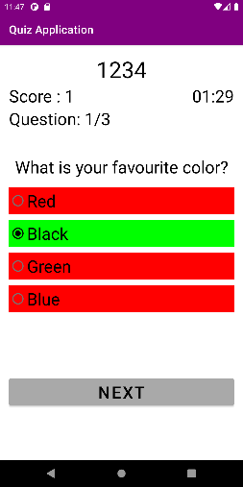

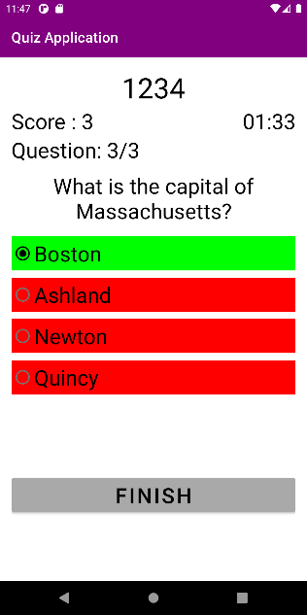 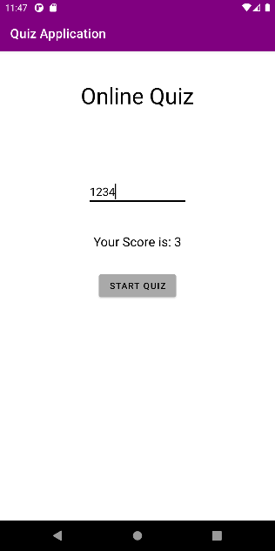

During the quiz if the back button is pressed twice, the quiz will be finished and score till then will be displayed as score. Once the quiz is finished, then the score on Student home page and database also will be updated.

1. **Instructor Home Page:**  If the user logged in as an instructor, the user will be navigated to instructor home page. In this page, the user can add quiz questions and view the scores by entering the quiz ID. Once the quiz Id is entered and use clicks on View Quiz Scores button, the scores will be displayed as below. Back Button on the scores page will navigate user to the Instructors Home Page.

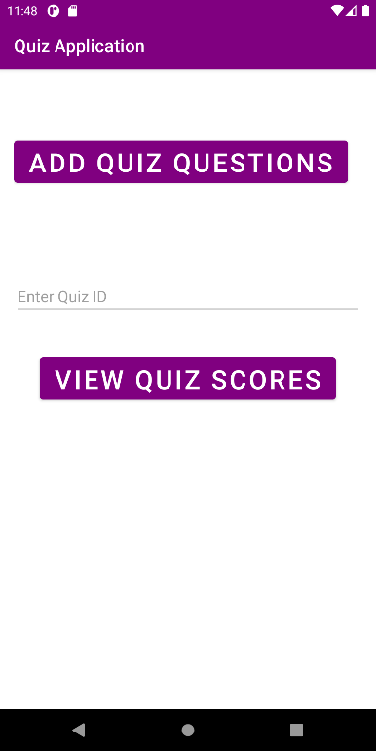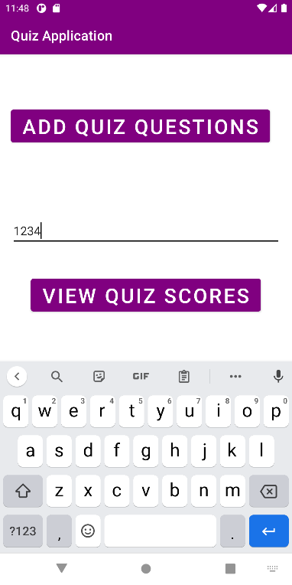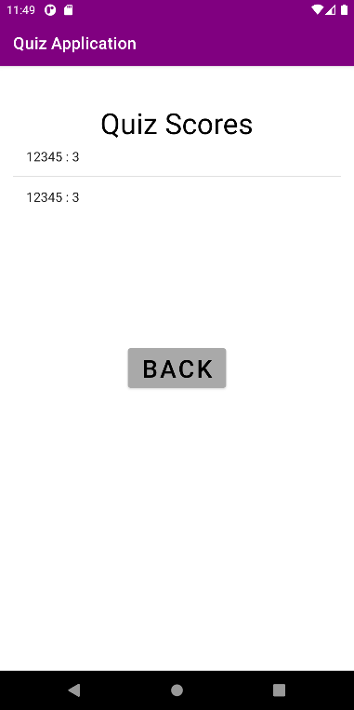

When the user clicks on Add Quiz Questions button, then the user will be taken to the Add Question Page.

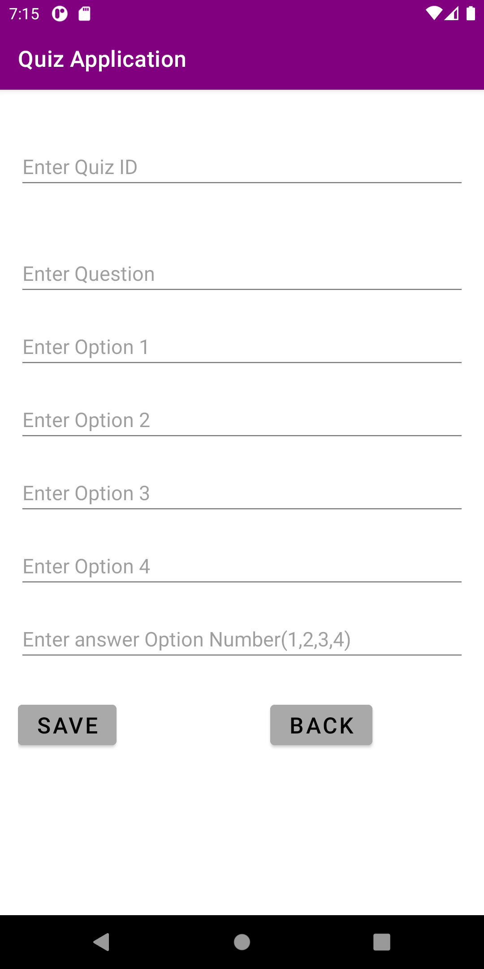 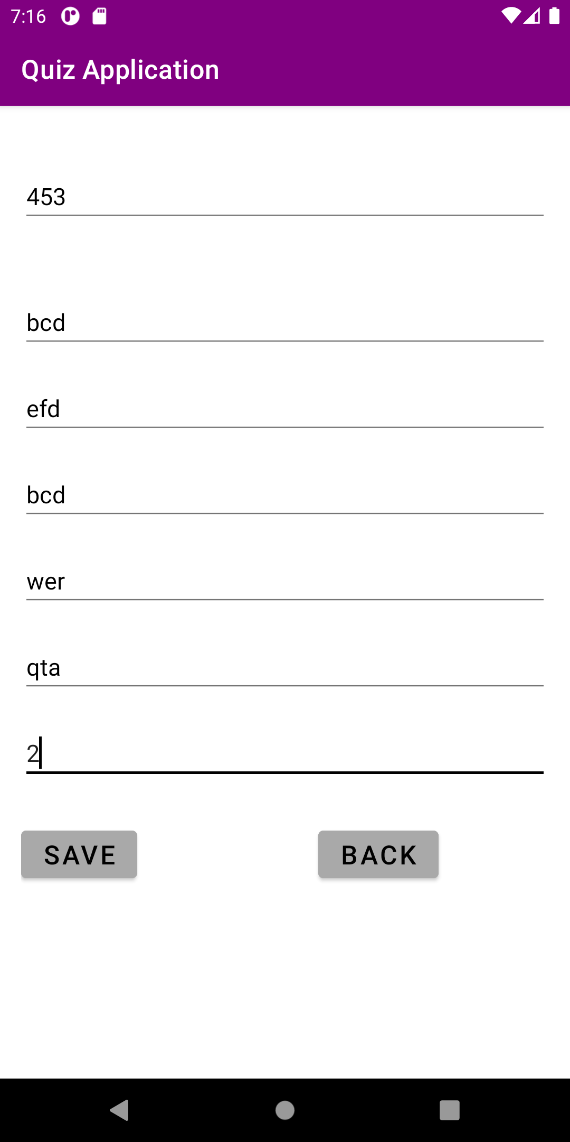 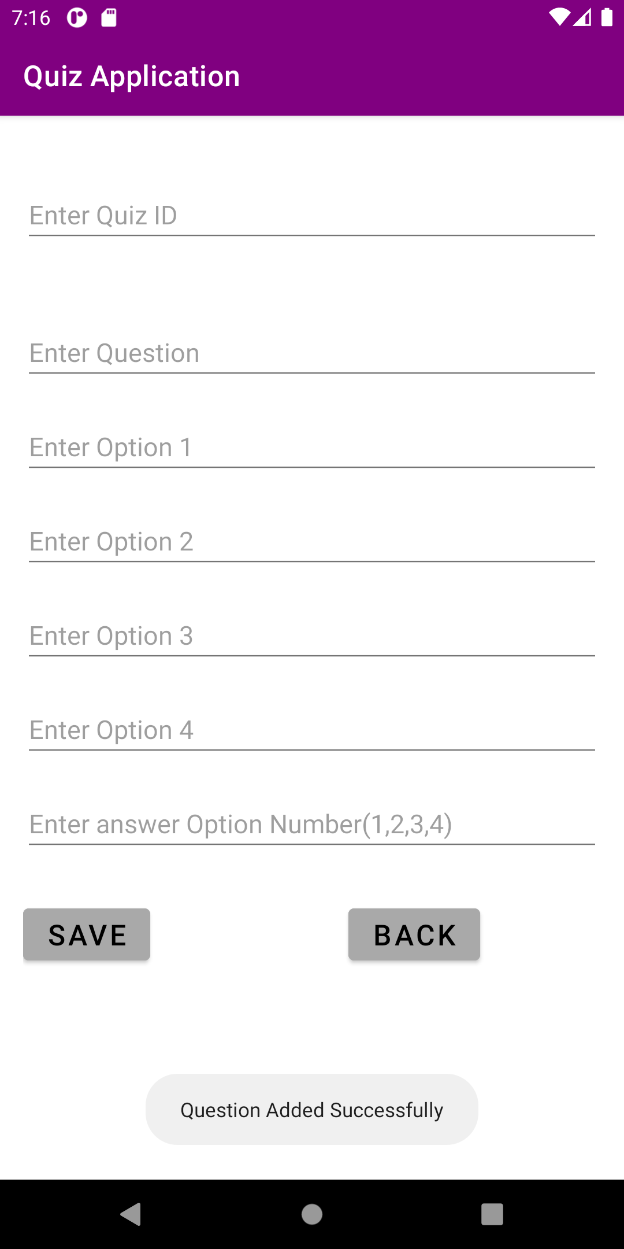

Once the save button is clicked, the question will be updated to database and the page refreshes. When the back button is clicked then the user will be taken to the instructor’s home page again. Here scores will be displayed on View Scores Page and Questions will be added in Add Question Page.

The reason for particularly mentioning the names of pages is, each page is associated to an activity. LoginActivity is for Login Page. StudentActivity is for Student Home Page. InstructorActivity is for Instructor Home Page. QuizActivity is for Quiz Page. AddQuestionActivity is for adding questions by the instructor. ViewScoreActivity is for displaying scores for the instructor.

**Application Implementation and Evaluation:** As described above, the app has several pages, and each page has an activity associated with that.

Along with that, we have a **QuizDbHelper.java** file which has all database related functions there like creating, updating and fetching data. All functions that involve database are there in this file.

There is a **QuizContract.java** which is class file that has table structures i.e., column names for the tables.

There is a **Question.java** which is a class file that defines the object question, constructor, getters and setters.

There is a **User.java** which is a class file that defines the object user, constructor, getters and setters.

There is a **Score.java** which is a class file that defines the object score, constructor, getters and setters.

If there must be data communicated between activities, then the data is passed through intent. For the activity result like the score after the quiz, it is passed through intent using shared preferences. I have attached Javadoc in the GitHub repository (index files).

I have tested the scenarios manually and modified the errors and improvements accordingly. Initially there are some issues with accessing the database but later I could solve them. I have only tested the app in Android Studio, and it worked always (never crashed after the final commit). While testing I have faced issues in sending and getting data from intent across activities but later, I could fix them.

**References:** I did not have important references for this project. Just took the help of internet while resolving errors especially related to database.

**Experiences and Thoughts:** Initially when I started, I thought this will be not that challenging. But on progressing, I got to know how organized and clear picture we should have to develop an application. With every error maybe we might have to change our implementation thoughts. Sometimes, even the smallest things took a lot of time debugging. Initially I though I would implement it quiz Level table but later I realized it is not that easy for me and it is taking a lot of time. So, I implemented it to question level which made me easy.

This is a very good learning and helped me improving my skills. During the whole process, I had a lot of confused thoughts, like I do one thing, but I have always in mind that some other thing might work better. But finally, this is a very good experience and by the end I thought like If I had some more time, I would have done much better. I knew my project will have some improvements but for the time being this is what I could do and may be off the academic record I will work on improving this.